**Assignment 4**

1.Print the result for every questions below: (6 marks)

i). Create the following list:

li1 :1,2,3,4,5,6,7,8,

li2 :0,1,4,5,6

ii).Add 9 to li1 and 7,8,9 to li2.

iii). Remove 3 and 4 from li1 and last item from li2.

iv). Print the length of li1 and li2

2.Which one is the correct way of creating the list (1 mark)

* 1. list names = [“Kailly”, “Merry”, “Charlie”];
  2. List num = [1,2,3,4,5,6,7]
  3. List greeting = {“hello”, “good morning”};

3.How to add the item “a” to following list:(1 mark)

List alphabet = [“f”, “e”, “g”, “h”];

1. alphabet.add(“a”);
2. alphabet.remove(“a”);
3. alphabet.add(a);

4. How to remove last item to the following list:(1 mark)

List alphabet = [“f”, “e”, “g”, “h”];

a. alphabet.remove(“h”);

b. alphabet.removeLast();

c. alphabet.remove(h);

5. How to get the number of items of the following list:(1 mark)

List alphabet = [“f”, “e”, “g”, “h”];

1. alphabet.len();
2. alphabet.length();
3. alphabet.length(a);

6. Print the result for every questions below: (6 marks)

i). Create the following map:

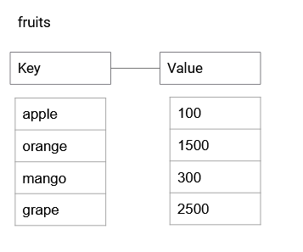

ii). Add the fruit “strawberries” which have a price of 2500.

iii). Remove mango from maps.

iv). Print the length of the fruits.

7. Which one is the correct way of creating the map(1 mark)

* 1. Map names = [“Kailly”, “Merry”, “Charlie”];
  2. Map<String, int> names = {

“Id0” : “Kailly”,

“Id1” : “Merry”,

“Id2” : “Charlie”,

}

c.Map<String, int> names = {“Kailly”, “Merry”, “Charlie”};

8. How to add the name “Jonny” with key “Id3” to following map:(1 mark)

Map<String, int> names = {

“Id0” : “Kailly”,

“Id1” : “Merry”,

“Id2” : “Charlie”,

}

1. names.add(“Jonny”);
2. name[“Id3”] = “Jonny”;
3. name[Id3] = “Jonny”;

9. How to remove “Merry” from the map:(1 mark)

Map<String, int> names = {

“Id0” : “Kailly”,

“Id1” : “Merry”,

“Id2” : “Charlie”,

}

1. names. remove(“Merry”);
2. name.remove(“Id1”);
3. name[“Id1”].remove();

10.How to print the length of map:(1 mark)

Map<String, int> names = {

“Id0” : “Kailly”,

“Id1” : “Merry”,

“Id2” : “Charlie”,

}

1. names.len();
2. name.length();
3. names.length();

11. Write the function which returns the sum of number (variable num).The variable called “num” has value 10. (int num = 10) Use while loop or for loop if necessary. (5 marks)

12. Write the function to open the door and close the door by inputting parameters as bool. (5 marks)

Hint : void main() {

openDoor(??); }